

**Name: Usama Habib**

**Regno: BCSP253027**

**Course: Information Security and Forensic Lab**

**Quiz: 1**

**Instructor: Sir, Moeez Javed**

**Practice Task 1:**

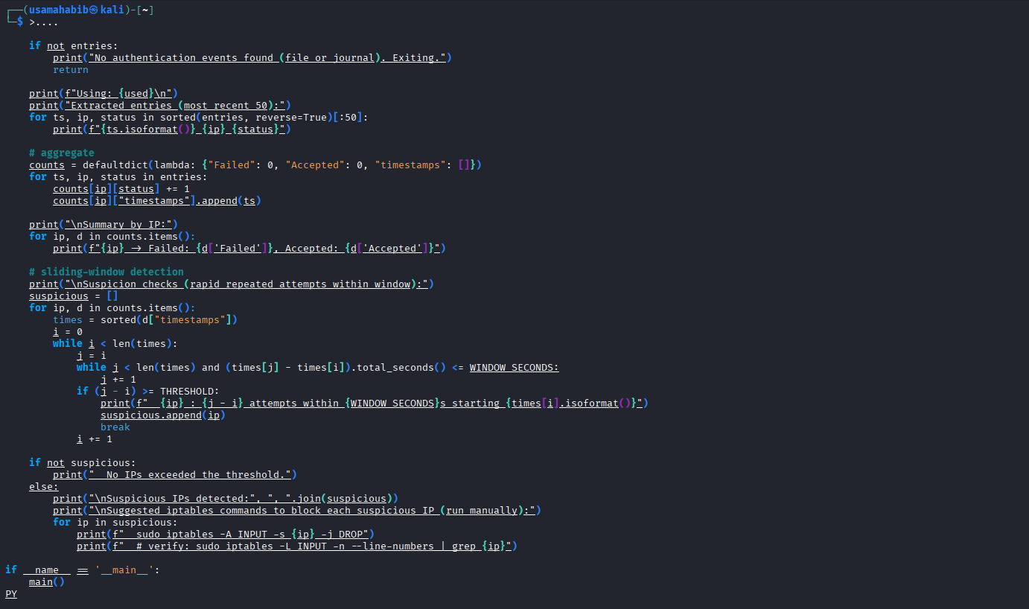

**sudo python3 ~/dikw_auth_parser.py**

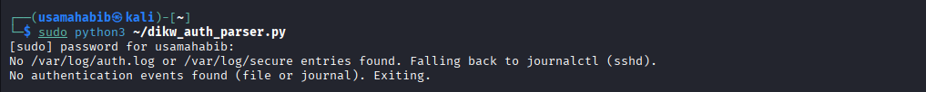

**sudo cp /var/log/auth.log /root/auth.log.backup.$(date +%F_%T) 2>/dev/null || sudo cp /var/log/secure /root/auth.log.backup.$(date +%F_%T) 2>/dev/null**

**# show backup (use sudo because /root is root-only)**

**sudo ls -l /root/auth.log.backup.* 2>/dev/null || echo "No backup found in /root"**



**sudo chown root:root /var/log/auth.log 2>/dev/null || true**

**sudo chmod 600 /var/log/auth.log 2>/dev/null || true**

**# or for /var/log/secure:**

**sudo chown root:root /var/log/secure 2>/dev/null || true**

**sudo chmod 600 /var/log/secure 2>/dev/null || true**

**# if you exported from journal:**

**sudo chown root:root /root/auth_from_journal.log 2>/dev/null || true**

**sudo chmod 600 /root/auth_from_journal.log 2>/dev/null || true**

**# verify**

**ls -l /var/log/auth.log /var/log/secure /root/auth_from_journal.log 2>/dev/null || true**

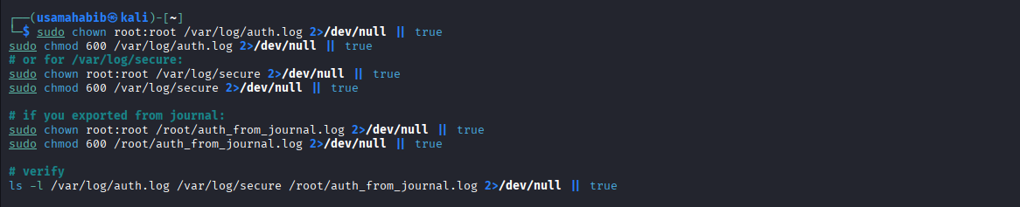

**sudo sha256sum /var/log/auth.log | sudo tee /root/auth.log.sha256 > /dev/null**

**sudo chown root:root /root/auth.log.sha256**

**sudo chmod 600 /root/auth.log.sha256**

**sudo cat /root/auth.log.sha256**

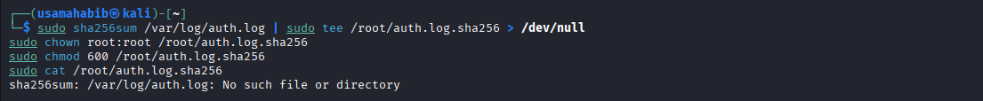

**SUSPICIOUS_IP="192.168.1.100"**

**# Add a DROP rule (immediate effect)**

**sudo iptables -A INPUT -s "$SUSPICIOUS_IP" -j DROP**

**# Show rule to confirm**

**sudo iptables -L INPUT -n --line-numbers | grep "$SUSPICIOUS_IP" || sudo iptables -L INPUT -n --line-numbers**

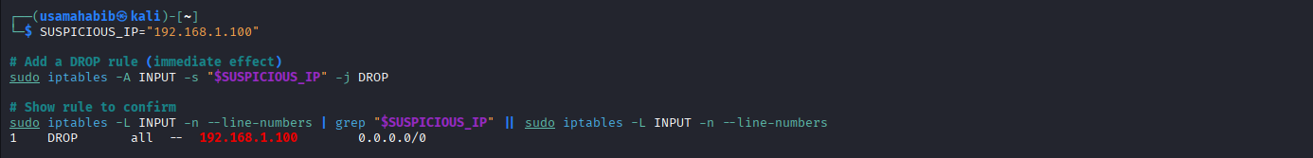

**Practice Task 2:**

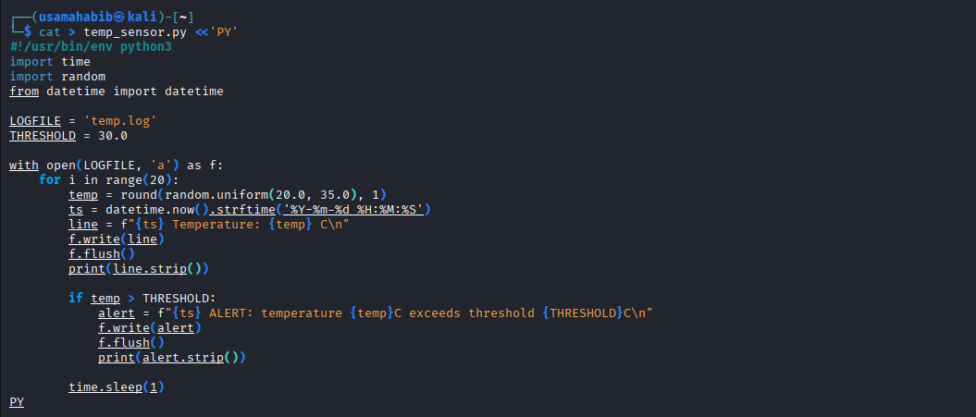

chmod +x temp_sensor.py

python3 temp_sensor.py

